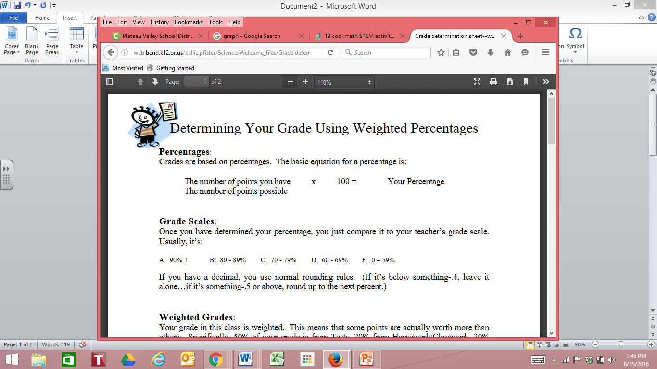

D: 65-69%

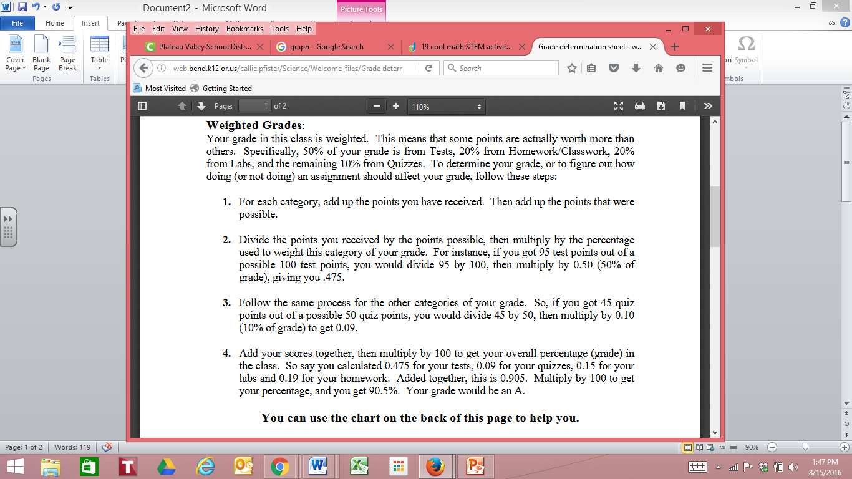

Steps for calculating weighted grades.

|  |  |  |
| --- | --- | --- |
| **Assignment** | **Points Received** | **Points Possible** |
|  |  |  |
|  |  |  |
|  |  |  |
|  |  |  |
|  |  |  |
|  |  |  |
|  |  |  |
|  |  |  |
|  |  |  |
|  |  |  |
|  |  |  |
|  |  |  |
|  |  |  |
|  |  |  |
|  |  |  |
|  |  |  |
|  |  |  |

|  |  |  |
| --- | --- | --- |
| **Assignment** | **Points Received** | **Points Possible** |
|  |  |  |
|  |  |  |
|  |  |  |
|  |  |  |
|  |  |  |
|  |  |  |
|  |  |  |
|  |  |  |
|  |  |  |
|  |  |  |
|  |  |  |
|  |  |  |
|  |  |  |
|  |  |  |
|  |  |  |
|  |  |  |
|  |  |  |

|  |  |  |
| --- | --- | --- |
| **Assignment** | **Points Received** | **Points Possible** |
|  |  |  |
|  |  |  |
|  |  |  |
|  |  |  |
|  |  |  |
|  |  |  |
|  |  |  |
|  |  |  |
|  |  |  |
|  |  |  |
|  |  |  |
|  |  |  |
|  |  |  |
|  |  |  |
|  |  |  |
|  |  |  |
|  |  |  |

**Category 1** **Category 2** **Category 3**

Total in previous box multiplied by category weight

Total of Points Received:

Total of Points Possible: 

Total points received divided by total points possible: 

Total of Points Received:

Total of Points Possible: 

Total points received divided by total points possible: 

Total in previous box multiplied by category weight

Total in previous box multiplied by category weight

Total points received divided by total points possible: 

Total of Points Possible: 

Total of Points Received:

Final Grade: Add the bottom boxes from each column together. This is the current grade percentage you have in this class.